1 - Habilitado supervisord no systemd maquinas SLES15-SP1

###Criar arquivo supervisord.service###

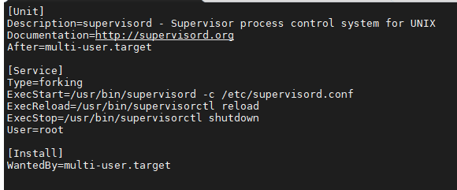

###Copiar abaixo###

[Unit]

Description=supervisord - Supervisor process control system for UNIX

Documentation=http://supervisord.org

After=multi-user.target

[Service]

Type=forking

ExecStart=/usr/bin/supervisord -c /etc/supervisord.conf

ExecReload=/usr/bin/supervisorctl reload

ExecStop=/usr/bin/supervisorctl shutdown

User=root

[Install]

WantedBy=multi-user.target

2 - Copiar arquivo “supervisord.service” para a máquina que está com o Supervisord, no caminho

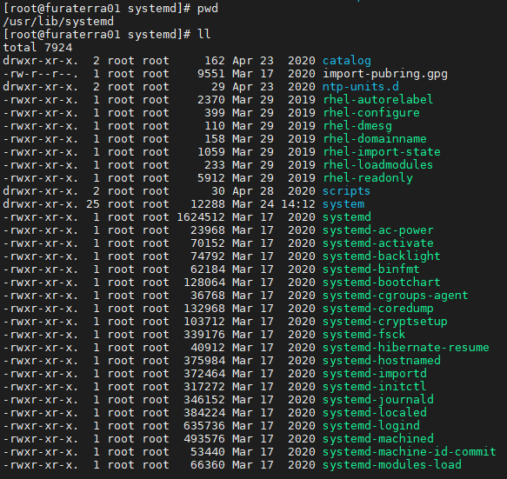

/usr/lib/systemd/system/supervisord.service

3 – Executar reload de daemon e subir o serviço, supervisord.

Systemctl daemon-reload

Systemctl start supervisord

